Structure & Navigation Clarity
Homepage
1.Homepage - Company Overview / Our Mission & Vision / Certifications & Accreditations / Our Team
2.Services – List them
3.Projects – Our Clients / Featured Projects / Completed Projects
4.Contact us

- Homepage
Diamond Edge Cutting is a leading specialist demolition contractor delivering safe, precise, and efficient solutions across all sectors of the construction industry.

DEC established operations in the United Arab Emirates in 2008, building on more than 15 years of prior experience across Ireland and Europe. DEC has successfully partnered with Major Developers, Main Contractors, and Consultants across the region on complex and technically challenging projects. Our core services include:

- Controlled and Structural Demolition
- Robotic Demolition (largest fleet in the Middle East)
- Wire sawing
- Wall sawing, track sawing, and floor sawing
- Core drilling
- Tunnelling, refinery, and kiln works
- Soft demolition and enabling works
- Specialist plant and equipment rental

Using advanced technology and modern methodologies, we execute both light and heavy demolition projects with speed, accuracy, and uncompromising safety standards. With a dedicated team of 300+ highly trained professionals, we deliver projects from concept to completion—on time, on budget, and to the highest standards of quality and safety.

Our Mission
To deliver innovative, safe, and efficient demolition solutions that exceed client expectations while maintaining the highest standards of quality, professionalism, and environmental responsibility. We are committed building long-term client relationships based on trust and performance

Our Vision
To be recognised as the leading specialist demolition contractor in the Middle East region, setting industry benchmarks for safety, innovation, and operational excellence.

Certifications & Accreditations
We are fully certified and compliant with international and local regulatory standards, including:
- ISO 9001 – Quality Management
- ISO 14001 – Environmental Management
- ISO 45001 – Occupational Health & Safety
- ICV (In-Country Value) Certified
- Dubai Municipality G+12 Approved Contractor
- Abu Dhabi Municipality Approved Contractor
- CICSPA Approved
- Guinness World Record

Our Team
Chief Executive Officer – Anthony Keever
Managing Director – Robert Aylward
Operations Manager – Conor Wade
Commercial Manager – Carl Riley
Finance Manager – Laxmikant Prajapat

- Services
2.1 Demolition Services

Controlled & Structural Demolition
We undertake major demolition projects where using large demolition machinery to all types of concrete/steel structures.
Typical demolition projects undertaken include high rise buildings, chimney towers, hotels, bridges and structures. We have a proven ability to adapt and diversify its plant and equipment to meet the demands of complicated demolition projects, while exceeding the highest safety standards. Using the latest equipment and technology, our highly experienced and professional workforce can provide an eco-friendly approach to demolition which enables us to minimize major environmental factors such as noise, dust, vibration and emissions.

Robotic Demolition
Our specialized Robotic Demolition fleet of equipment (The largest fleet of its type in the GCC) is used in applications to achieve more efficient and safer demolition solutions where the trained operators can perform the demolition away from the workface with total control of the high-risk environment to ensure safe operational completion of the project. These electric machines are the perfect solution where noise and emissions are a constant constraint in heavily operational areas such as Airports & Malls.

The RDM’s (Robotic Demolition Machines) are also specifically mandated for use in refractory work across the GCC including cement plants, Steel plants & Aluminum plants.

Wire Sawing
Wire sawing is an environmentally friendly concrete cutting solution, with minimal noise or air pollution. With wire sawing there are no limits to sawing depth. This method is ideal for cutting large deep cuts with almost no restriction on cut size, and can be used to cut out bridge sections, large beams and columns. It can be used to form openings in thick reinforced concrete structures such as dams, retaining walls or any large section of concrete or masonry. Other applications include cutting steel tanks, steel shafts, under water pipes and even large underwater piles & pier walls.

Wall Sawing / Track Sawing
When your focus is on precision and accuracy, Diamond Edge Cutting’s range of track mounted wall saws provide a fast and accurate solution to creating openings in reinforced concrete, brick, block & masonry.

DEC has trained and experienced personnel for wall sawing also known as track sawing. It’s one of the most affective, fastest and safest way to remove concrete sections & for isolating. We can cut flush to existing structures leaving a smooth, clean cut precisely where required without creating dust or vibration.

Core Drilling
Diamond Edge Cutting employs the latest drilling technology using electric, hydraulic or pneumatic powered drill rigs to drill extremely accurate holes with no dust or vibration for a wide variety of applications. Holes can be drilled vertically (either up or down), horizontally or at an angle through a wide range of materials including masonry, reinforced concrete, steel beams and columns encased in concrete, granite, tiles, asphalt etc.

Diamond Edge Cutting has successfully core-drilled holes up to 24metres deep and can offer a large range of standard drill sizes from 14mm to 600mm diameter. Special non-standard sizes can be made to order. Typical applications include service holes and openings for pipes, conduits and cables, core samples for testing purposes, holes with rebates for runway lights etc.

Refinery / Kiln Works / Tunnelling
Diamond Edge Cutting Robotic Demolition machines are the ideal specialist equipment for carrying out demolition works safely in confined spaces, we specialize in removing the slag to kilns in preparation for refractory lining works to aluminium, steel & cement plants and provide a cost-effective solution to underground tunnelling cross passages

Floor Sawing & Road / Apron Sawing & Sealing
For an accurate and efficient means of cutting slab surfaces such as roads, runways, bridges, piers or floor slabs, Diamond Edge Cutting’s large fleet of saws provides the perfect solution for cutting expansion joints, cutting break lines for trench excavation or sawing large openings in floor slabs.

Our petrol and diesel saws are suited to outdoor work and our electric floor saws are suited to indoor work or when working in sensitive areas where low noise and emission-free sawing is required. Our blades are water cooled, which suppresses the dust, and by combining the correct blades with the right saw Diamond Edge Cutting will provide you with a quick and cost-effective solution to your cutting needs.

Soft Demolition
Strip out of non-structural elements from inside and outside of building to facilitate demolition or re-designing works. Diamond Edge Cutting can undertake the works as a whole strip out package back to shell & core or selected strip out as per customer’s requirement.

2.2 Specialist Plant Rental
Earthmoving & Excavation (Excavators, Loaders)
Material Handling and Lifting (Forklifts)
Demolition Robots (Brokk and DXR)
Bulk Handling (Breakers, Crushers, Grabs, Sheers, others)

- Projects
Our Clients
Emaar, Shamal, Damac, Expo, Omniyat, DMT, Mudon, Veolia, Dutco, Al Tayer Stocks, Khansaheb, Refcon, Vale, Drydocks, Engineering Office, Alec, Enoc, Al Naboodah, KPS etc

Projects
- Project Name
- Location
- Scope of Work
- Key Highlights
- Pictures

Also group by category:
- Residential
- Airports
- Commercial
- Hotels
- Industrial
- Infrastructure

Completed projects

DMT
CCAD
Al khail mall
Dubai Mall
Nas Arena
Demolition of 90m High RCC Chimney
Demolition of Expo Centre at Dubai International Airport

Meena Plaza – Abu Dhabi
Controlled Demolition, Wrapping and Protection Works
Vale Oman Pelletiser Plant – Sohar Oman
Removal of Refractory Linings
Controlled Demolition Works (Crunching) and disposal of debris
DWC - Al Maktoum International Airport
Facade Demolition
Cleveland Clinic – Abu Dhabi
Controlled Demolition Works (Cut & Carve) and disposal of debris
Marsa Al Arab – Dubai
Demolition of 3600 Bar, Verdana Beach Building and concrete elements on two breakwaters including slipway
Jumeirah Beach Hotel - Dubai
Hotel Strip Out Works and disposal of debris
ICD Brookfield - Dubai
Demolition using Robotic Demolition Machines.
Dubai Mall Fashion Dome – Dubai
Return Shop Units Back to Shell & Core (9,692m2) and disposal of debris
One Za’abeel Project – Dubai
Wire sawing and controlled demolition of Waler Beams
Expo 2020 Enabling Works
Concrete Demolition and Recycling Works
Deira City Centre Cinema Expansion
Controlled heavy and soft demolition and removal of debris off site
Dubai International Airport Expansion, Concourse 4 Project.
Controlled demolition of 23 Northern Apron Buildings and removal of debris off site
Dubai Festival City Upgrade - Phase 1 & 2
Controlled heavy and soft demolition and removal of debris off site
Abu Dhabi International Airport, A380 Stands & Aprons, T1 Passenger Segregation
Concrete cutting and drilling, controlled heavy and soft demolition
Dubai International Airport Expansion, Terminal 2 Project
Concrete cutting and drilling, controlled heavy and soft demolition and removal of debris off site
Mall of the Emirates Remerchandising
Strip out and removal of debris off site
Concrete Chimney Tower, Jebel Ali, Dubai
Complete demolition of a 90m concrete chimney tower to ground level using our specially designed spider robotic machine

- Contact Us
4.Contact Us –
Dubai, UAE
Tel: (+971) 4 370 6434
Email: info@diamondedgecutting.com
Office Address: Plot 597-604 DIP 2, Dubai UAE
Abu Dhabi, UAE

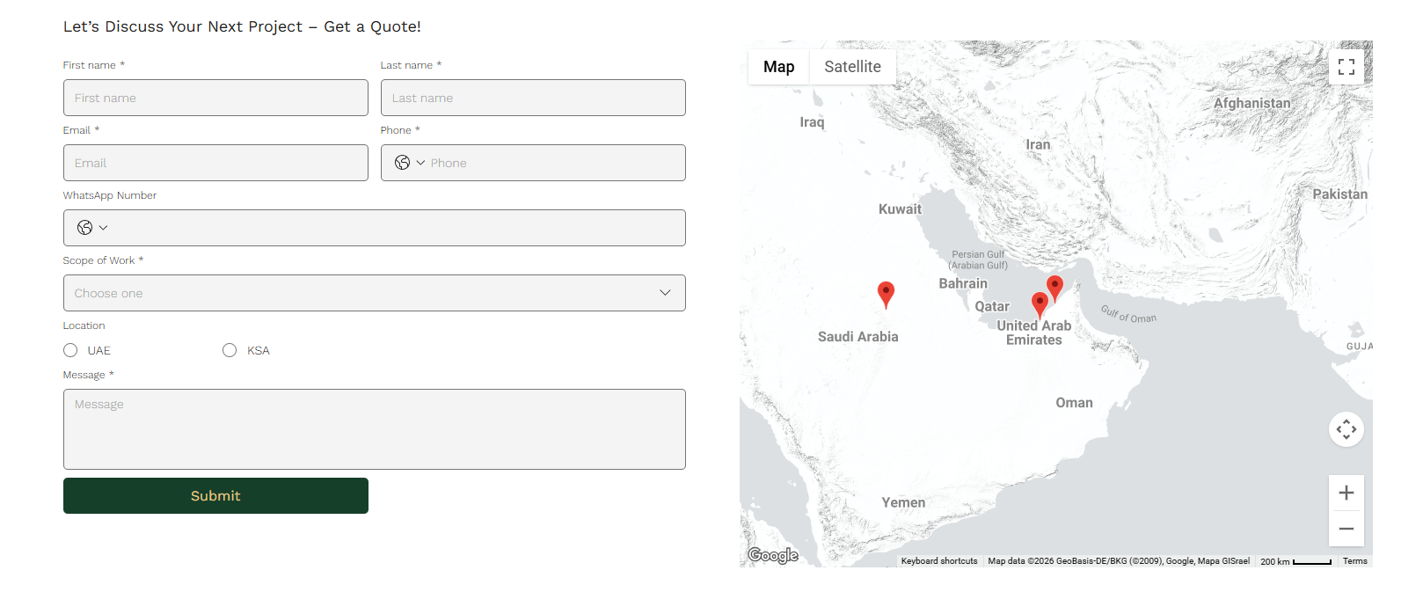

Brand color – Red, gray and white

